

DASHBOARD DESIGN NOTES
EV Market Analysis Dashboard
Based on the supplied ev_market_train dataset and Dashboard Design Template
Project Detail | Value
Date | 20 October 2026
Team ID | Roll 58
Project Name | EV Market Analysis Dashboard using Tableau Public / Streamlit
Maximum Marks | 5 Marks
Dataset | ev_market_train.csv
Dataset Size | 200,000 records × 37 columns

Activity 1: Interactive and Visually Appealing Dashboard
The dashboard will turn the EV dataset into an interactive visual summary of vehicle sales, manufacturer performance, vehicle categories, battery technology, driving range, price, ratings, geography and model years. The design should help users find comparisons quickly and understand the measures without manually scanning a large spreadsheet.

1. Clear and Intuitive Layout
- Place the dashboard title and a short description at the top.
- Use a first row of KPI cards: total recorded annual sales, average range (km), average price (USD), and average customer rating.
- Arrange charts in logical sections: Sales Overview; Battery & Performance; Price & Range; Customer, Geography & Sustainability.
- Keep chart titles, axis labels, units, legends and number formats consistent.

2. Use Appropriate Visualizations
Dashboard View | Dataset Fields | Recommended Visual | Purpose
Sales by Manufacturer | manufacturer, annual_sales_units | Horizontal bar chart (top manufacturers) | Compare recorded sales across manufacturers.
Sales by Vehicle Category | category, annual_sales_units | Sorted bar chart | Identify categories with higher recorded sales.
Battery Technology | battery_type | Bar chart or donut chart | Show the distribution of battery types.
Range & Efficiency | category, range_km, efficiency_wh_per_km | Bar chart and scatter plot | Compare range and energy efficiency across categories.
Price vs Range | price_usd, range_km, category, manufacturer | Scatter plot | Explore how price and range vary across vehicles.
Charging Performance | max_dc_charging_kw, charging_dc_fast_time_min, charging_ac_time_hr | Bar chart / scatter plot | Compare charging capability and charging time.
Customer & Safety Ratings | customer_rating, safety_rating_stars, manufacturer, category | Bar chart | Compare recorded customer and safety ratings.
Geography & Model Year | manufacturing_country, market_region, model_year, annual_sales_units | Bar chart and line chart | Explore recorded sales by country, region and model year.
Sustainability & Use Case | co2_saved_tons_per_year, recommended_use_case | Bar chart | Compare recorded CO₂ savings and recommended use cases.

3. Colour and Theming
- Use a clean white or very light-grey background with dark navy headings.
- Use a consistent blue/teal palette for sales and technical metrics; use one accent colour for selected filters or highlights.
- Use the same colour for the same category across all charts and maintain readable contrast.
- Avoid excessive gradients, decorative effects and too many colours.

4. Interactive Filters and Slicers
Recommended filters: manufacturer, model_year, manufacturing_country, market_region, category, battery_type, drivetrain and recommended_use_case. Keep filters grouped in a sidebar or a compact top row. Ensure charts update consistently when filters are applied.

5. Drill-Down Capabilities
Allow users to move from overall sales to a manufacturer, then to its categories or models. Allow country/region and model-year comparisons where supported. Tooltips should show the relevant model/manufacturer, sales, range, price and rating values without overcrowding the charts.

6. Responsive Design
Use a grid layout that adapts to laptop and smaller screens. On narrow screens, stack KPI cards and charts vertically, avoid tiny labels, and keep the filters easy to access. Test the dashboard at the screen size used for the project demonstration.

7. Custom Visuals and Icons
Use simple, consistent icons for sales, battery, range, price, rating and sustainability KPI cards. Icons should support recognition rather than replace text labels or units.

8. Use of Infographics
Include a compact insight panel that summarizes the most important patterns in the selected data. Use callouts only when the calculation is verified, and show units and filters applied so the user can understand the context.
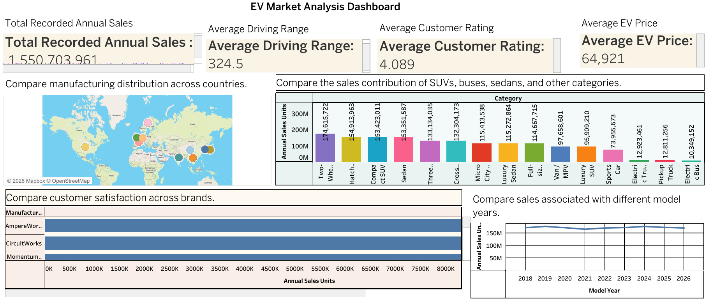

Major Outcomes / Preliminary Dataset Observations
- AmpereWorks has the highest summed recorded sales in this dataset. Its summed annual_sales_units value is 9,453,209, the highest among manufacturers in this file. This is a dataset-level comparison, not proof of global market leadership.
- Two-Wheeler Scooter leads the category sales aggregation. The category has 174,615,722 summed recorded annual sales units. A sorted bar chart will make the differences among categories easier to compare.
- NMC is the most frequent battery type in the records. It appears in 67,673 records. A battery-type chart should distinguish record count from sales volume, because they measure different things.
- The dataset supports comparison of price and driving range. The mean recorded range is 324.5 km and the mean price is $64,921. A scatter plot of price_usd against range_km can show patterns and outliers, but does not establish causation.
- Customer ratings are generally high on average, but some values are missing. The mean available customer_rating is 4.09/5. There are 3,977 missing customer-rating values, so rating visuals should disclose the number of available records.
- Data-quality checks are needed before final reporting. The file contains 2,028 missing annual-sales values and 1 fully duplicated row(s). Validate missing values, data types and unusual values before publishing final KPIs.
Overall outcome: The dashboard will provide one interactive place to explore recorded EV sales and compare technical, pricing, rating, geographic and sustainability fields. All findings should be described as patterns in the supplied dataset, and the dashboard should clearly disclose missing data and aggregation choices.
